**Quantitative Methods**

**Final Exam**

**Fall 2010, Hill**

**Part One: Long-Answer** *Answer the following questions thoroughly, using your own words to define, explain, and illustrate.*

1. Define ***distribution***. Define and describe, with examples, what a distribution is, how we assess and understand it, and why it is important to understand. Why does the distribution matter for *descriptive statistics*? Why does it matter for *inferential statistics*, and what is its role in the calculation of inferential statistics? (15 points)

2. Describe the distribution of the variable **house value**, shown in the histogram below. (5 points)

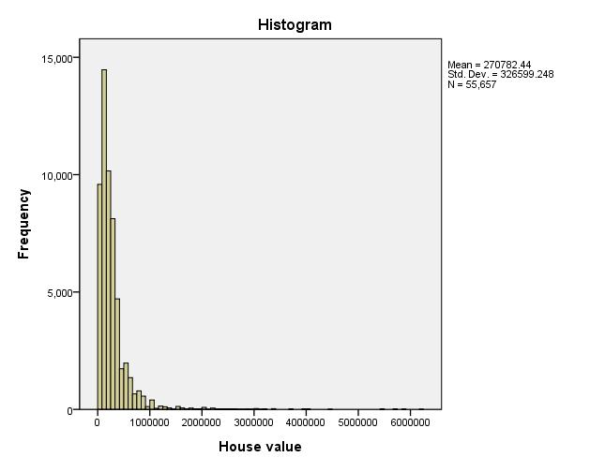

**Part Two: Interpretation of Statistical Methods, Output, and Results**

*About this data: the data from which this output is generated is real data from the American Community Survey, administered by the U.S. Census. The survey asks about demographics, family composition, income and benefits, insurance, education, disabilities, and other questions about day-to-day life in the United States. The government uses the results to help plan new programs and set policy.*

3. Interpret the following output. Indicate the type of hypothesis test used. Specify the dependent variable and the independent variable(s). What might the researcher be trying to do, and what do you suppose the hypothesis is? In detail, interpret the results—describing the results with a conversational tone, but also reporting the important technical details. (15 points)

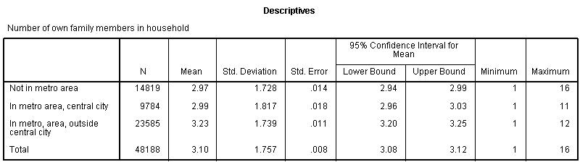

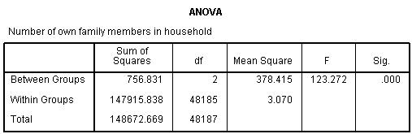

*additional room to answer question 3*

4. Interpret the following output. Indicate the type of hypothesis test used. Specify the dependent variable and the independent variable(s). What might the researcher be trying to do, and what do you suppose the hypothesis is? In detail, interpret the results—describing the results with a conversational tone, but also reporting the important technical details. (15 points)

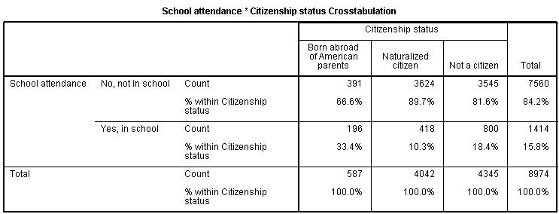

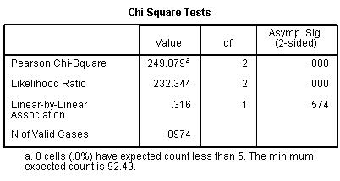

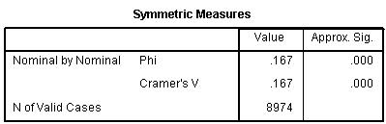

*additional room to answer question 4*

5. Interpret the following output. Indicate the type of hypothesis test used. Specify the dependent variable and the independent variable(s). What might the researcher be trying to do, and what do you suppose the hypothesis is? In detail, interpret the results—describing the results with a conversational tone, but also reporting the important technical details. (15 points)

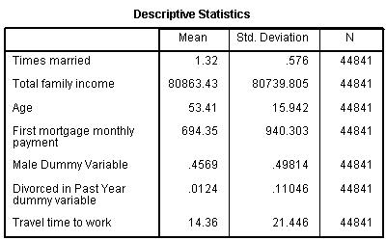

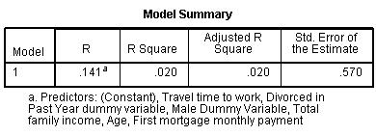

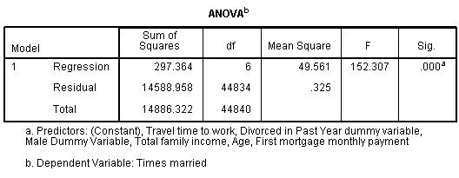

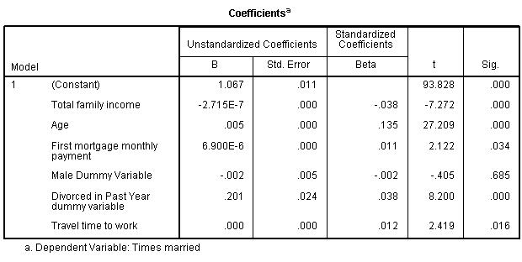

*additional room to answer question 5*

5b. What does the following output add to your understanding of the output in question 5? Do you see any potential problems? How do you know whether or not these problems exist? (5 points)

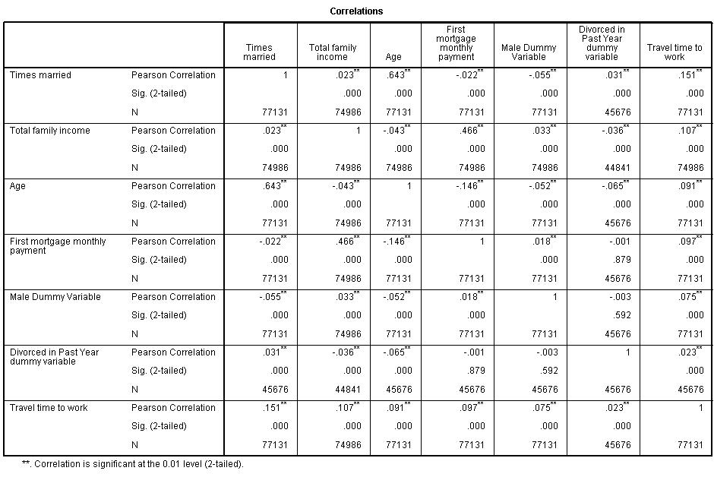

6. Interpret the following output. Indicate the type of hypothesis test used. Specify the dependent variable and the independent variable(s). What might the researcher be trying to do, and what do you suppose the hypothesis is? In detail, interpret the results—describing the results with a conversational tone, but also reporting the important technical details. (15 points)

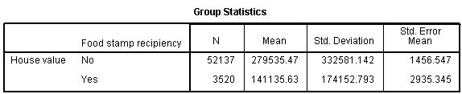

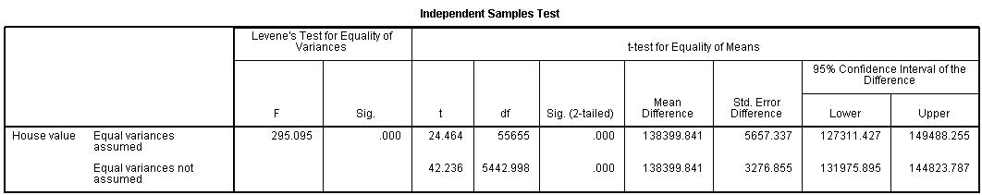

7. Was the dummy variable ***divorced in the past year*** created correctly? Answer yes or no, and in one or two sentences explain your answer. (5 points)

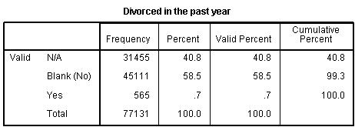

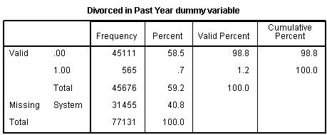

8. Suppose you have two variables, **total personal income** (measured as low, medium, or high) and **travel time to work** (measured as *0 travel time*, *less than 10 minutes to travel to work*, and *10 minutes or longer to travel to work*). A researcher calculated the Gamma statistic on these two variables and got a result of 0.622. Explain why the researcher calculated this statistic, what it will be used for, and interpret the results. (5 points)

9. Explain the difference between **standard deviation** and **standard error**. (5 points)